**Nama : Niko Ahmad Fauzi**

**NIM : 1127050117**

**Kelas : IF-B**

- State dan Activity Diagram Vending Machine -

1. State Diagram

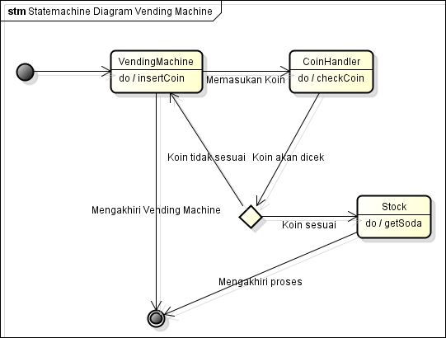

1. Activity Diagram

